**Reservation Management System(Railway)**

**Q1. For the above problem Capture the requirement of the client and document them, also review it with acceptance criteria**

1. INTRODUCTION

1.1 Purpose

This document gives detailed functional and non-functional requirements for railway registration management system. The purpose of this document is that the requirements mentioned in it should be utilized by software developer to implement the system.

**1.2 Scope:**

“Railways Reservation System” is an attempt to simulate the basic concepts of an online Reservation system. The system enables to perform the following functions:

SEARCH FOR TRAIN

BOOKING OF A SELECTED FLIGHT

PAYMENT

CANCELLATION

Freight Revenue enhancement

Passenger Revenue enhancement

Improved & optimized service

**1.3. Overview**

This system provides an easy solution to the customers to keep track reversion

GENERAL DESCRIPTION

The railway reservation system facilitates the passengers to enquiry about the trains available on the basis of source and destination, booking and cancellation of tickets, enquiry about the status of the booked ticket.

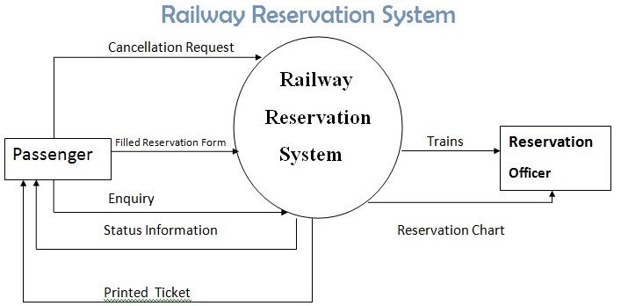

**2.1 User Manual**

The system should provide Help option in which to operate the system should be explained. Also, soft copy of the ticket should be given to the user in a invoice form.

3. FUNCTIONAL REQUIRMENT

**3.1. Description**

The identity of the customer is verified and then Should enter to the railway reservation system. The system should display customer photograph along with their name id proof. The system should send e-mail after successfully booking the ticket.

**3.2. Technical Issues**

The system should be implement in VC++

4. INTERFACE REQUIRMENTS

**4.1 GUI**

GUI 1: Main menu should provide options such as Login, forget password, Help.

GUI 2: In Login menu he able to login to main page of railway reservation system

GUI 3: The display of interface should be (see fig.4.1)

The photo can be clicked to edit the details

The Gmail button can be clicked to send email of ticket

and invoice

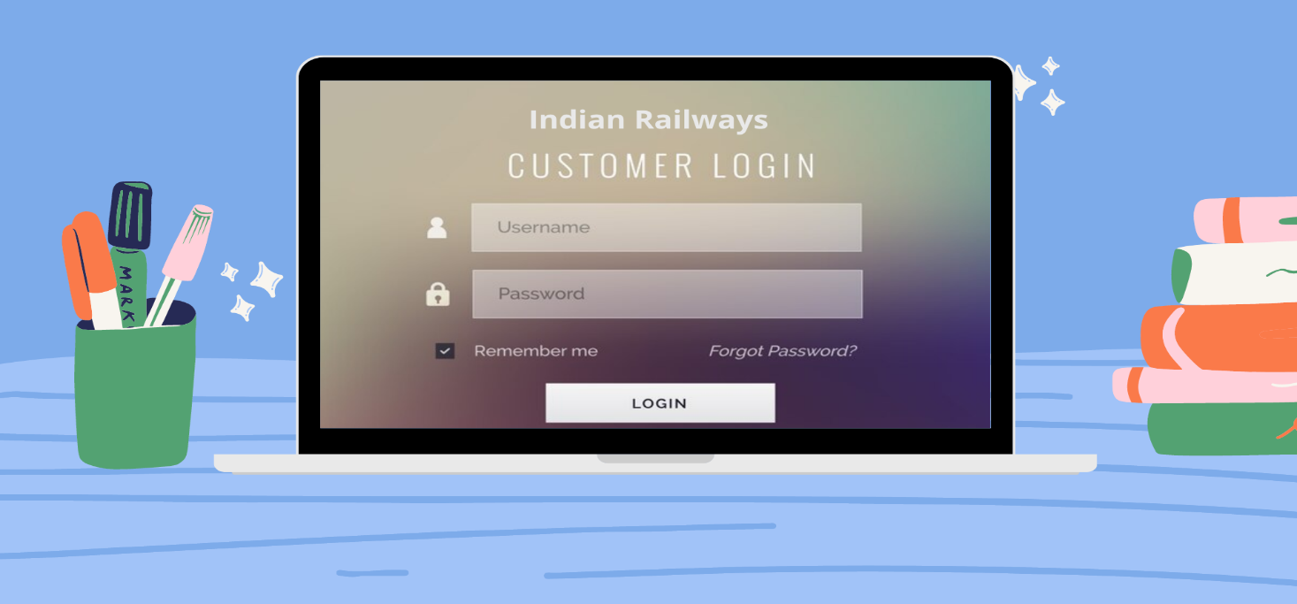

FIG.4.1 CUSTOMER LOGIN PAGE

GUI 4: Help option should describe functionality of the system.

It should be Written in simple HTML.

**4.2 Hardware Interface**

Hardware Interface 1: The system Should be embedded in the Laptop.

Hardware Interface 2: The Laptop Should use Wireless Ethernet card to send e-mails. These Laptop should be clients of department database server.

**4.3 Software Interface**

Software Interface 1: Railway reservation system.

Software Interface 2: E-mail message generator which generates standard message

Software Interface 3:Report generates

5. PERFORMANCE REQUIREMENTS  
The e-mail should be sent within a minute after booking ticket

The system should work on any device any place and anytime

6. DESIGN CONSTRAINTS  
 The system should be designed within 8 Months.

7. OTHER NON-FUNCTIONAL ATTRIBUTES

**7.1 Security**  
 The system should provide password to login on to the system. He/she should be able to see their personal details

**7.2 Reliability**

Due to wireless connectivity , reliability cannot be guaranteed.  
**7.3 Availability**

The system should be available all browsers  
**7.4 Reusability**

The same system will be used for booking tickets again and again

8. OPERATIONAL SCENARIOS

The railway reservation database will contain customer name, mobile number, Gmail id etc...

9.PREMLIMINARY SCHEDULE

The system has been implemented within 9 Months

**2. Identify and Document a least two associated risks for the above case study**

**The type of Risks that may be associated with our project is as follows:**

**1. Project risks:** Project risks concern differ forms of budgetary, schedule, personnel, resource, and customer-related problems. A vital project risk is schedule slippage. Since the software is intangible, it is very tough to monitor and control a software project. It is very tough to control something which cannot be identified. For any manufacturing program, such as the manufacturing of cars, the plan executive can recognize the product taking shape.

**2. Technical risks**: Technical risks concern potential method, implementation, interfacing, testing, and maintenance issue. It also consists of an ambiguous specification, incomplete specification, changing specification, technical uncertainty, and technical obsolescence. Most technical risks appear due to the development team's insufficient knowledge about the project.

**3. Create user stories and UML diagram for the above requirements**

**user stories for railway reservation management system**

**INTRODUCTION**

In this SRS it states the purpose of Railway Reservation System is to create and cancel reservation viewing train information, reservation details, updating train and reservation details and generate reports.

**SCOPE**

The scope of the system in creating reservation is that, is that from any railway station we can create reservations, which will be automatically updated in all stations. Hence, there is no confusion to the reservation clerk in all station to create reservation.

**USER STORY**

AS A Customer

I WANT TO Reserve a seat in train

SO THAT I can visit my native.

**SCENARIO 1**

GIVEN Reservation page

WHEN The all seats are booked

THEN I should book a train seat for next scheduled time

**SCENARIO 2**

GIVEN Confirmation booking train ticket

WHEN I have to cancel due to some emergency

THEN Pay cancelation fee

**ACCEPTANCE CRITERIA FOR SCENARIO 1**

Accepting that all the seats are booked for this scheduled train timings so I have to book seat for the next scheduled train timings destined for my native place. By reserving a seat, it will be automatically updated in all stations and I can board to the nearest railway station.

**ACCEPTANCE CRITERIA FOR SCENARIO 2**

Accepting that I have booked a train ticket according to my timings and destined place . Unfortunately, I have to cancel my ticket due some emergency issues and pay the cancellation fees for cancelling ticket at the end moment. The cancellation of ticket will be updated in all railway station system. For the above problem Capture the requirement of the client and document them , also review it with acceptance criteria.

UML diagram for railway reservation of management system

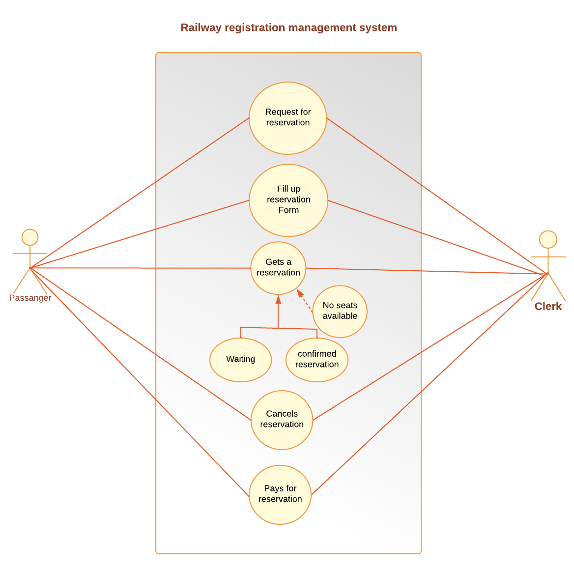

**4. Write the test suite for the above requirement**

**Test case**

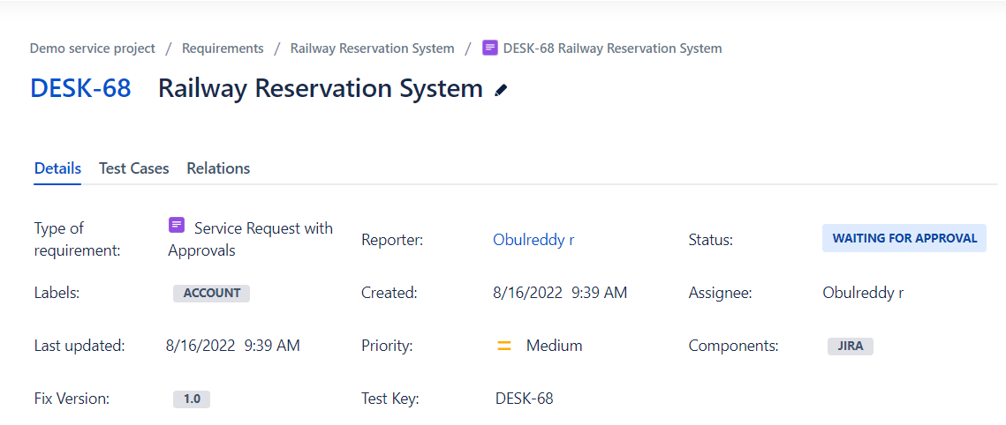

**Test plan**

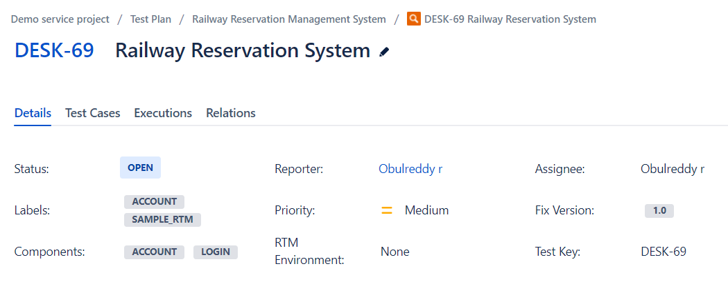

**Test Execution**

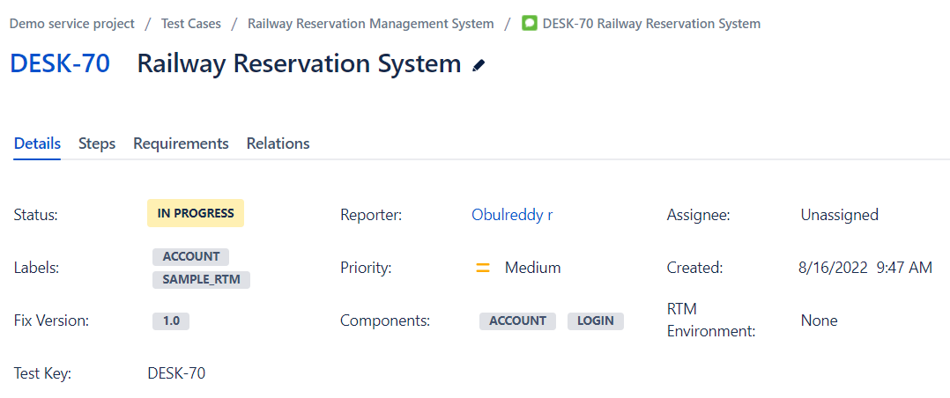

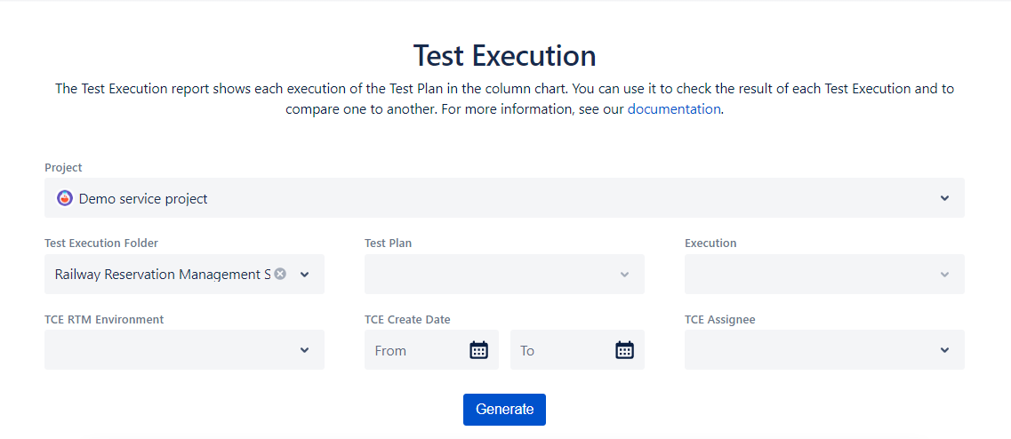

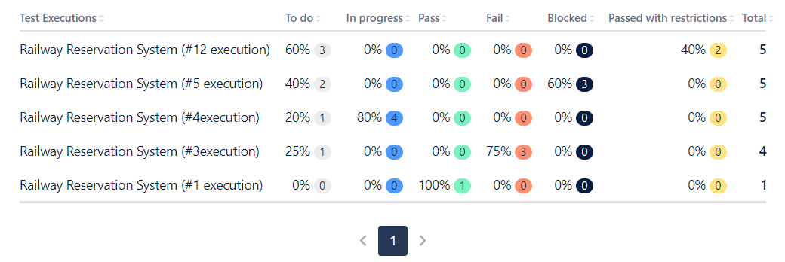

**Output of graph**

